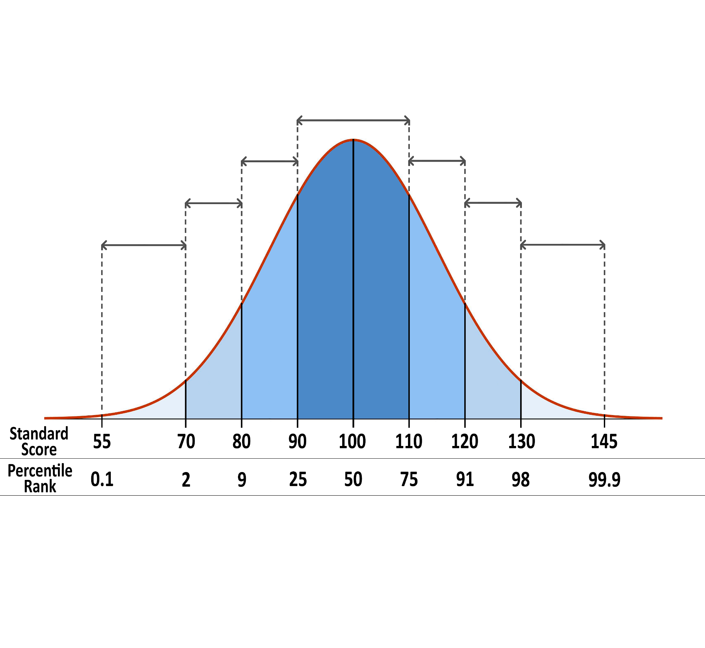

**Extremely**

**Low**

**Very**

**Low**

**Low**

**Average**

**Average**

**Very**

**High**

**Extremely**

**High**

**High**

**Average**