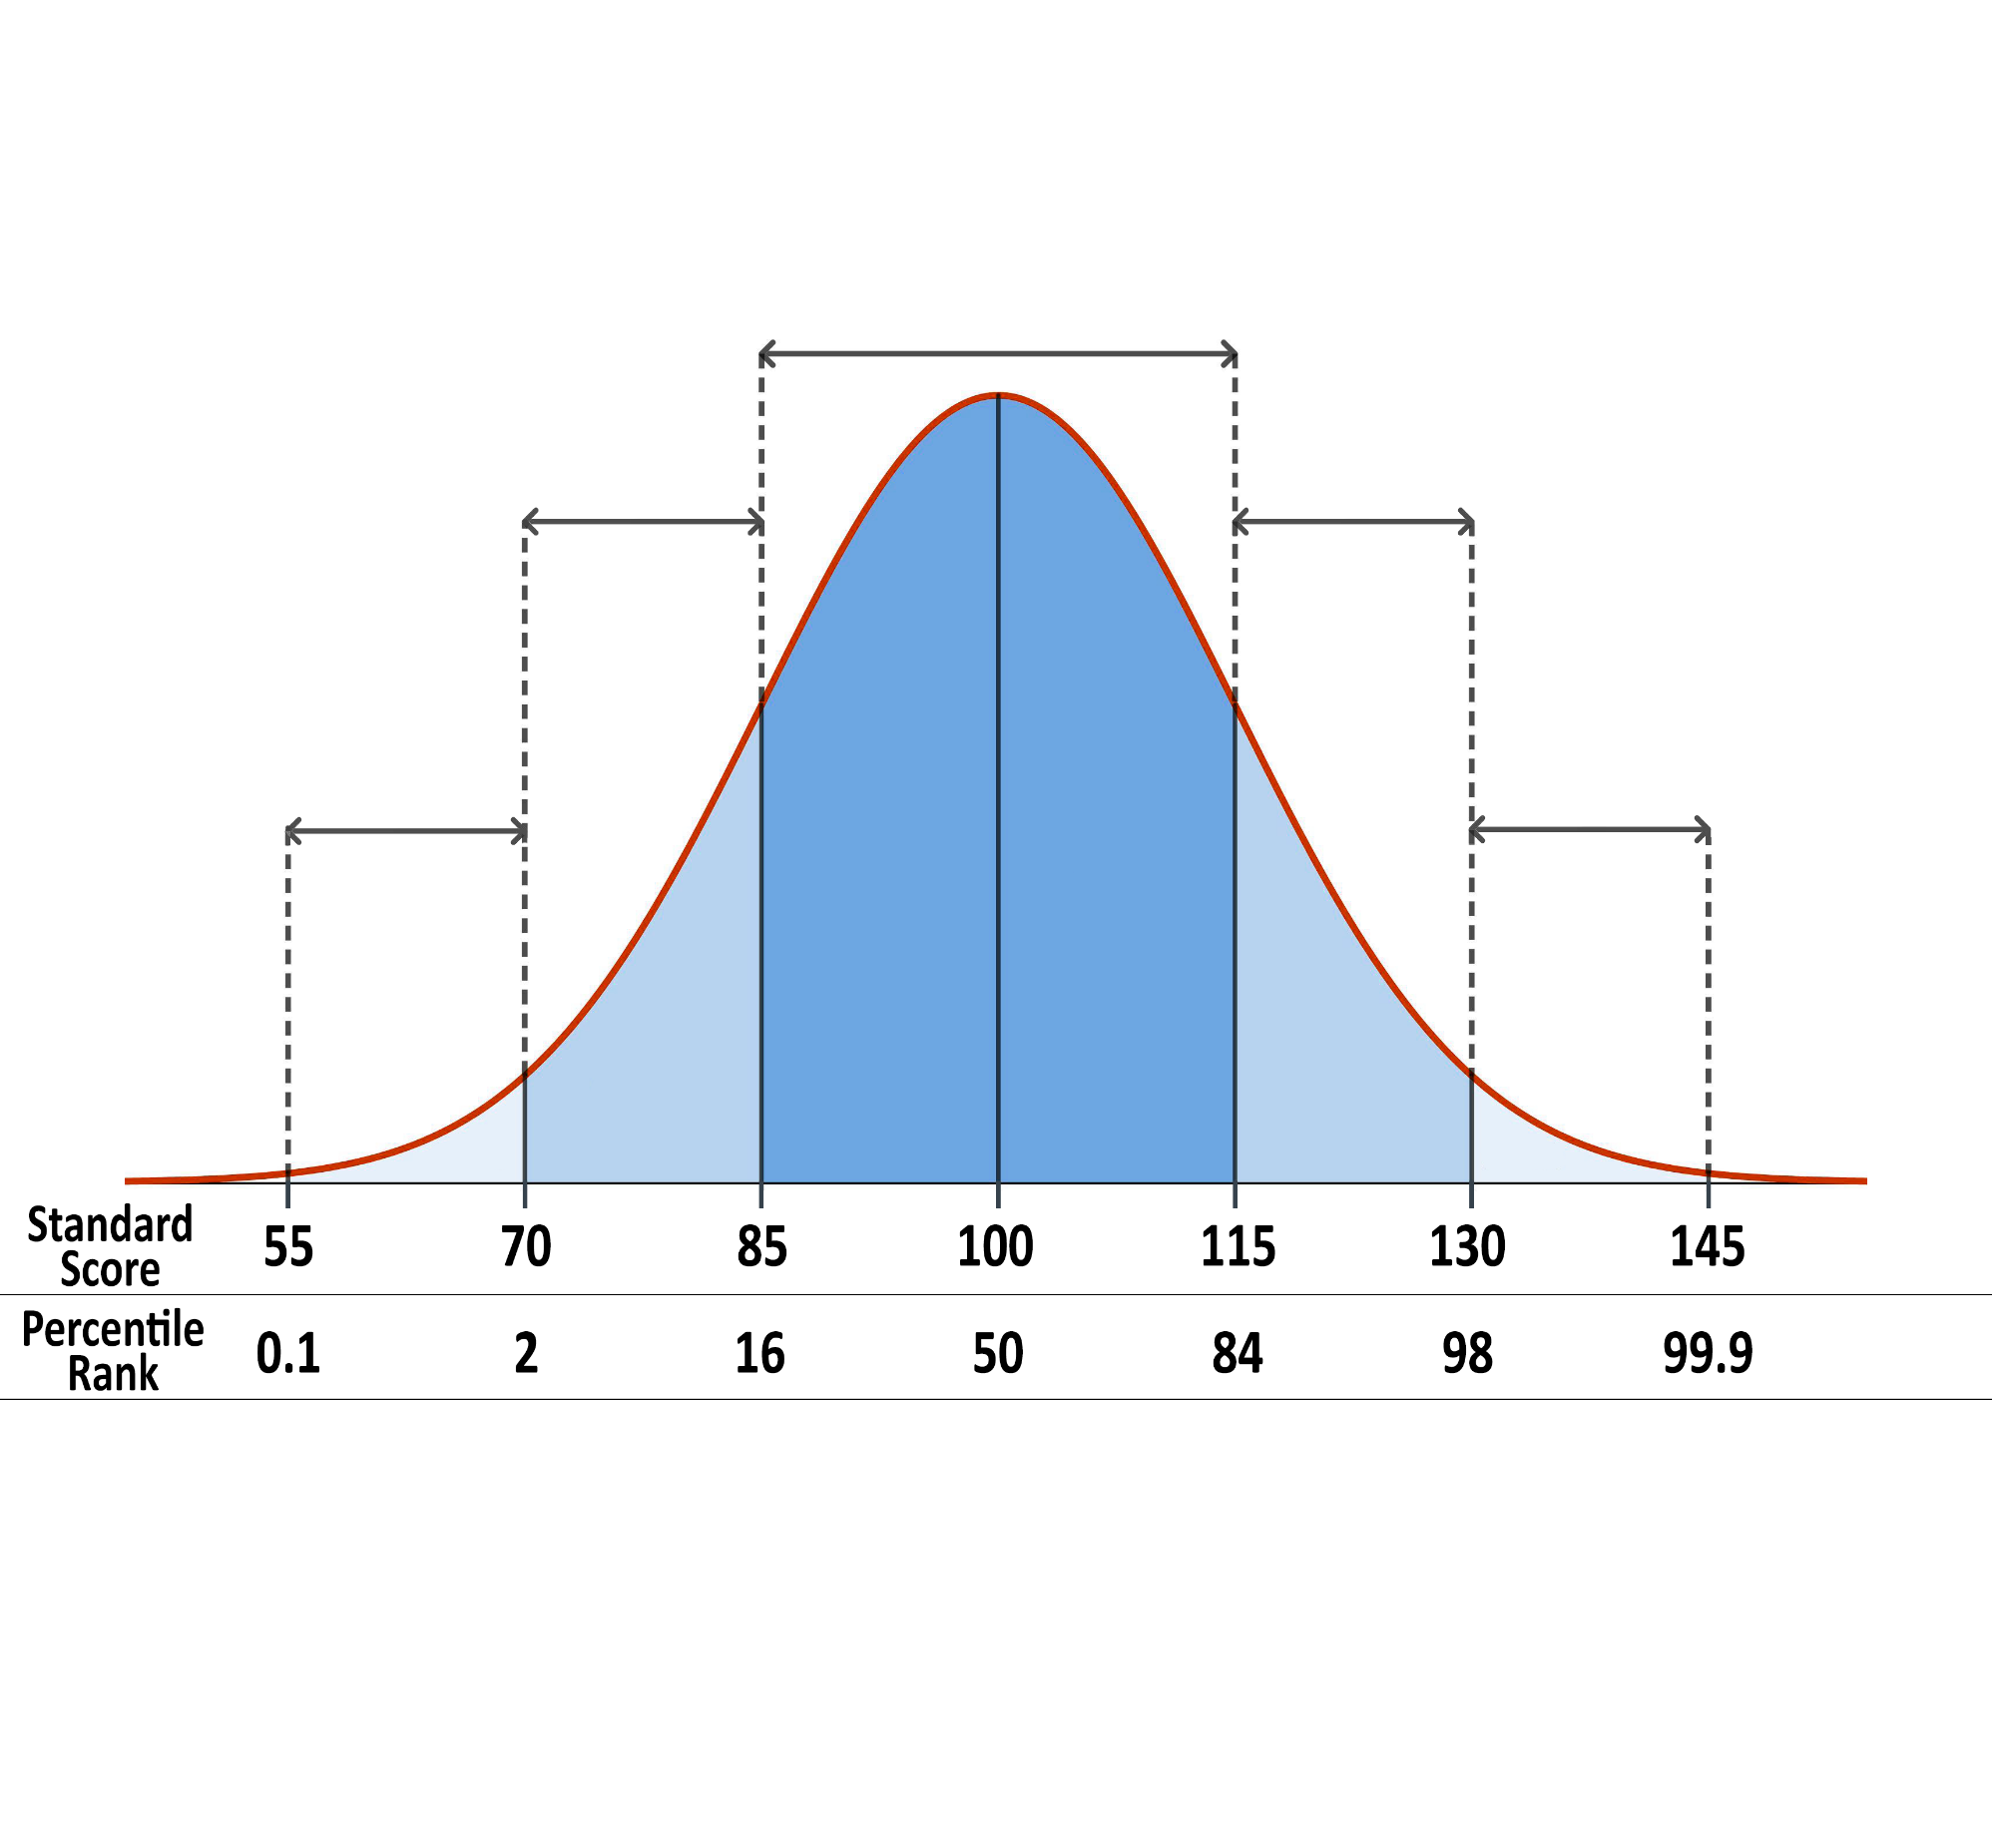

**Significantly**

**Below**

**Average**

**Below**

**Average**

**Significantly**

**Above**

**Average**

**Average**

**Above**

**Average**