**Understanding Standard Scores Using the Bell Curve***How your child’s scores compare to same-age peers*

This bell curve shows how students score on standardized tests compared to others their age. Most students score near the middle, with about two-thirds falling in the average range. Fewer students score at the far ends (or “tails”) of the curve, which represent less common scores that are much lower or higher than average.

Standard scores show how your child performed compared to same-age peers and help us understand whether their score falls below, within, or above the average range. For example, scores between 85 and 115 are considered average, with 100 being the middle of the scale.

Percentile ranks show the percentage of students your child scored better than. For example, a percentile rank of 50 means your child scored as well as or better than 50% of other students the same age, which places them in the exact middle of the scale.

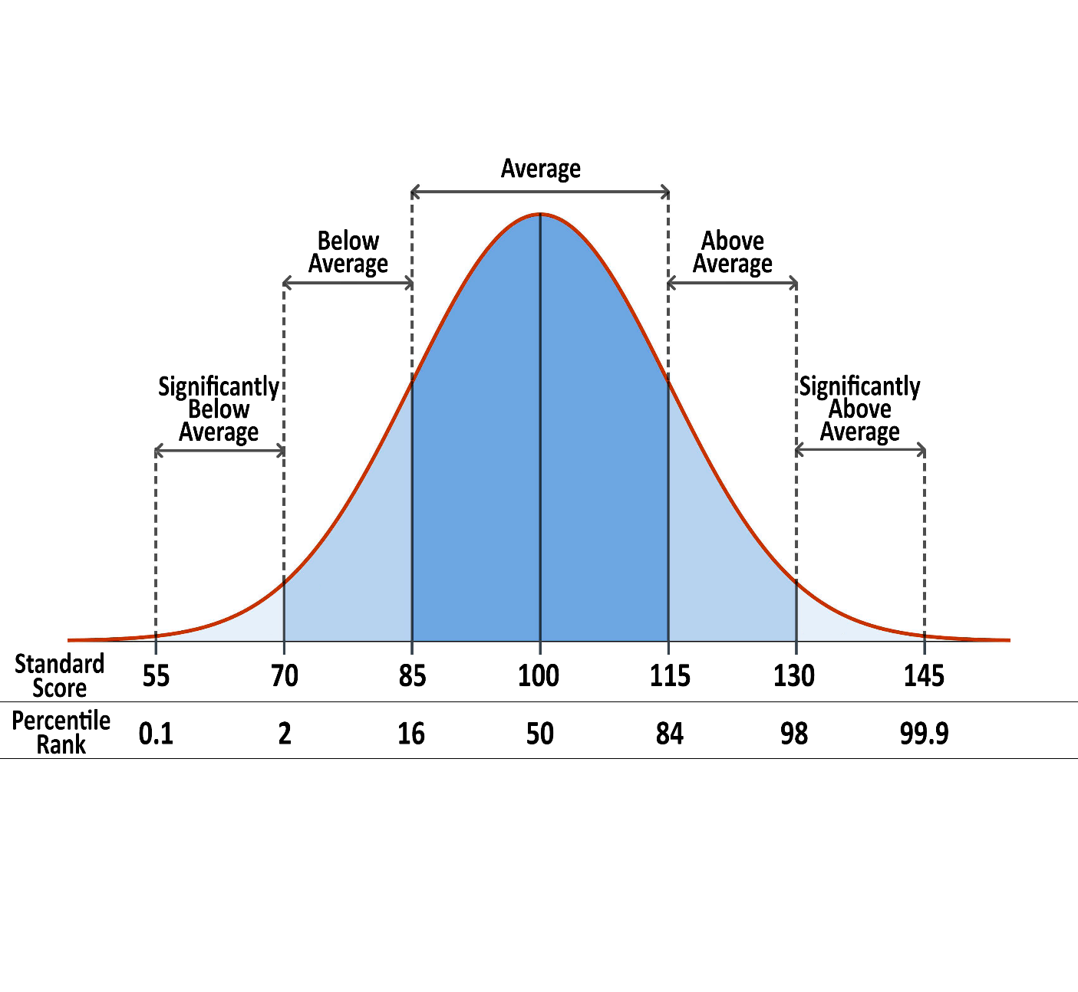

**Important Notes:**

* No single score tells the whole story. We always look at a full picture of your child’s strengths and areas of need when interpreting results.
* Some standardized tests may use slightly different labels or score ranges. For example, some define the average range as 90–109 instead of 85–115.
* Every child has a unique learning profile. These scores help guide support, but they don’t define a child’s potential.